Faculty Tech Tips Sheet

How to make PDF Documents more accessible

Instructions
- Launch Adobe Acrobat Pro on your device
- Open the existing PDF file containing the image you want to add alt text to or create a new file
- Select File and navigate to Properties. Under the Description Tab, enter the Document Title.

How to Check Accessibility
- Expand the Accessibility panel from the ribbon on the right side of the page.
- Review the menu panel on the right. You will be using Set Alternate Text, Reading Order and Accessibility Checker.
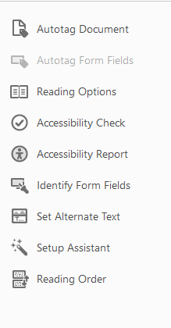
- Select the “Set Alternative text” option from the drop-down menu
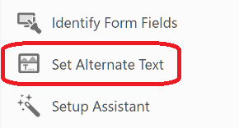
- Add a brief, descriptive text for the image in the "Description" field. This text should describe the content and purpose of the image. If the image is not the part of the document, mark the “Decorative figure” option with a tick.
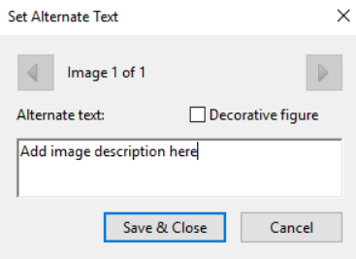
- Select “Save & Close” button to save changes when you are done
- Select Reading order from the menu.
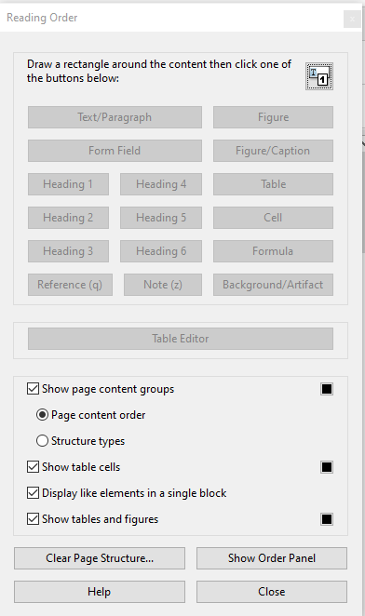
- Select Show Order Panel
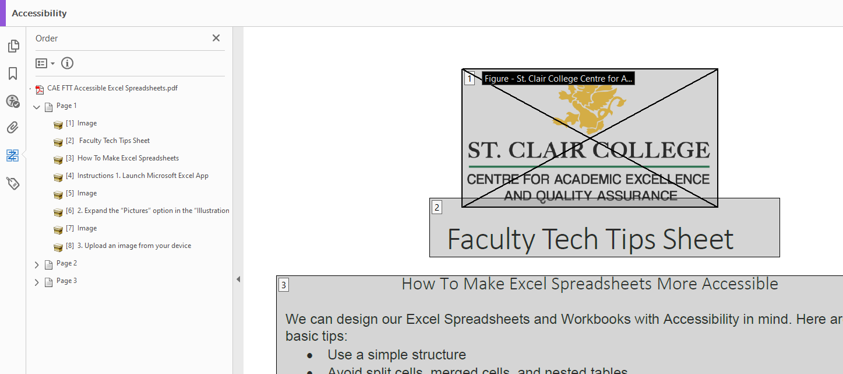
- Drag items that are out of order using the panel on the left. If there is a numbered item that has no text or image, select the number on the panel and delete.
- Select Accessibility Checker

Resources
- Adobe has additional instructions on using Reading Order and Accessibility Check.
- An overview of accessibility features in Adobe is available.
This work is licensed by St. Clair College under a Creative Commons Attribution-NonCommercial ShareALike 4.0 International License. Last edited: 2023-02-27

