Faculty Tech Tips Sheet

Adding Alternate Text to an Image in Microsoft Office 365

The process for adding Alt-tags in Microsoft products such as Word, PowerPoint, Excel, and Outlook is similar. There are two methods: Use the Picture Tools and Right-click the image.

Use Picture Tools
For Word and PowerPoint, you can use the Picture Tools menu:

Word Picture Menu

PowerPoint Picture Menu
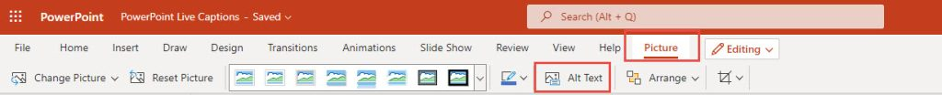
- Click on the first visual object.
- Locate and select the Picture menu using the main menu at the top of the window.
- Select Alt Text from the Picture menu,
- A panel will appear on the right with a space to enter your description for PowerPoint, and a space for both a Title and a description for Word.
- Select the next visual object with this panel open and you can continue to add Alt text for all the visual objects in your document quickly.
- Denote purely decorative images or objects by adding "" - these two quote marks will signal a decorative image for screen readers.
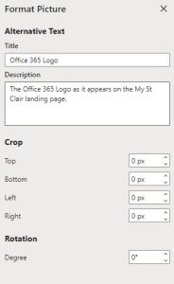

Right-Click on the Object
If you have included an image, chart, or other visual object,
- Right-click on the object, this will open a drop-down menu.
- Select Add Alternate Text.
- In the new dialog box that appears, type a description into the box or, in some cases, you will be asked for a Title and a description. The Title can be a short phrase or identifying word, but the description should be 1 - 2 sentences.
- If the image or object is purely decorative, you denote this by adding "" - these two quote marks will signal a decorative image.
Three Right-click menus
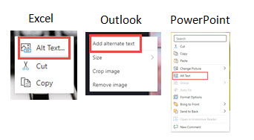

Resources

Microsoft Guides: Adding Alternative Text in Microsoft 365 and Everything you need to know to write effective alt text.

This work is licensed by St. Clair College under a Creative Commons Attribution-Non Commercial Share Alike 4.0 International License. Last edited: 2023-02-21

