Faculty Tech Tips Sheet

Adding Alternate Text to An Image on Instagram

Alternative text (also known as "alt text") is important for images on Instagram for several reasons such as accessibility, search engine optimization and usability.

Instructions
- Open your web browser and go to www.instagram.com
- Log in to your Instagram account and make sure that the ribbon on the left hand-site appears.
How to Add Alternate Text to An Image
- Select “Create” button on the ribbon on the left side of the website to upload an image to your Instagram profile.
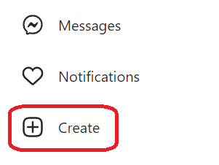
- Choose and upload the image you want from your computer or device
- Select the “Next” button in the upper right corner after the “Crop” window pops up.
- Select the “Next” button one more time to skip filter and adjustments options.
- Expand the “Accessibility” tab to open accessibility options for an image.
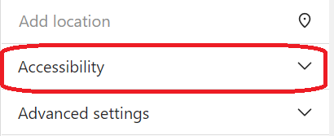
- Type a concise and accurate description of the image in the “Write alt text…” field.
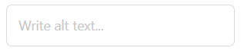
- Preview your post to make sure everything looks good, and then select "Share" button to post your image with the alt text included.
- The alt text will now be added to the image. When the post is published, the alt text will be read by screen readers to users who are blind or have low vision.
Here are a few tips and tricks for adding alt text to images on Instagram:
- Keep it concise: Alt text should be short and to the point. Try to summarize the content of the image in one or two sentences.
- Be accurate: Make sure the alt text accurately describes the content of the image. Avoid using vague or misleading descriptions.
- Use keywords: If the image is related to a specific topic or concept, consider including relevant keywords in the alt text. This can help users who are searching for information on that topic to find your image.
- Avoid duplication: If you are including a caption or text in your post that describes the image, there is no need to repeat that information in the alt text. Instead, focus on providing additional context or details about the image.
- Preview your post: Before you post your ideas and images, make sure to preview it to ensure that the alt text is displayed correctly and that the image looks good. This will help you catch any errors or formatting issues before you select "Share" button.

Resources
Read a short article that demonstrates adding alt text to an image on Instagram: Why You Should Add Instagram Alt Text to Your Posts (+ Tutorial!)
Watch a short video describing the process of adding alt text on Instagram
An overview of Alt Text is available from Instagram Help Center
This work is licensed by St. Clair College under a Creative Commons Attribution-NonCommercial ShareALike 4.0 International License. Last edited: 2023-01-06

