Faculty Tech Tips Sheet

Live Captioning in PowerPoint for In-class Presentation

PowerPoint Online for Microsoft 365 can transcribe the words you say while presenting and display them as captions in the language you speak or as subtitles translated to another language. When presenting in the classroom, using the microphone installed on the instructor station will work. You may need to angle the computer station to face where you will be speaking from. Also, the use of captions requires a reliable internet connection throughout your presentation.

Instructions
- Sign in to your My St. Clair account.
- Select Office 365 Dashboard
- Select PowerPoint Online from the menu on the left side of the screen,
- Open the presentation of your choice.

How to Activate Subtitles
- Select Slide Show from the top ribbon and select Use Subtitles on the Slide Show ribbon tab.
- Click Subtitle Options to customize your options.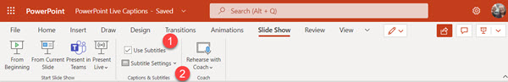
- Select Spoken Language to see the voice languages that PowerPoint can recognize and select the one you want. The language you select should be that you are speaking while presenting.
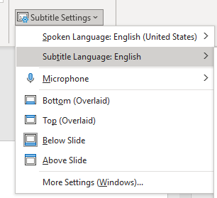
- Select Subtitle Language to see which languages PowerPoint can display on-screen as captions or subtitles and select the one you want. This selection is the language of the text shown to your audience.
- In the Subtitle Settings menu, set the position of the captions or subtitles. They can appear above or below the slide or on the top or bottom of the slide itself (overlaid). Note that overlaid captions may obscure information on the slide. We recommend Above Slide for classroom presentations.
- Start your slideshow.
- Turn subtitles on or off using the menu that appears at the bottom left of your slideshow while presenting full screen.

Resources
Watch a video: How to use PowerPoint captions and subtitles to present more inclusively by Mike Tholfsen.
Microsoft has additional instructions available: Live Captions in PowerPoint

This work is licensed by St. Clair College under a Creative Commons Attribution Non Commercial ShareAlike 4.0 International License. Last updated: January 25, 2023

