Faculty Tech Tips Sheet

Compressing an Image with Optimizilla

Introduction
Optimizilla is an online tool used to compress image size. An image that is a JPG, 400 pixels wide, and less than 500 KB is our target for uploading to Blackboard. This will display well and load quickly.

Instructions
1. Navigate to the Optimizilla site and locate the upload tool. It should show in the middle of your window but you may need to scroll to the bottom.
2. Drag and drop your image(s) or select the Upload Files button and select your image(s).
NOTE: The queue has a max of 20 files. Meaning, if you select more than 20 images, only the first 20 will be uploaded. You can always upload more once you are finished by refreshing the page or by selecting the Clear Queue button.
3. Wait for all the images to upload and compress. You will know when an image is compressed when the Download button appears at the bottom of the image.
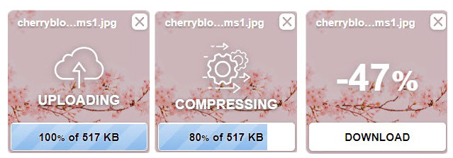
Once you see the 'Download' button at the bottom of the image, you can select it to download that image.

Resources
Optimizilla: compress images and photos online blog post from SupportHost.
How to use Optimizilla.com to compress your images for web use - YouTube Walkthrough
NOTE: Using the Download All button will give you a zip file containing all the images compressed. This basically "packages" all your images to ensure that no data is lost when you are downloading the file. If you do not know how to unzip a file, download each image individually or watch the quick YouTube tutorial.
This work is licensed by St. Clair College under a Creative Commons Attribution-Non Commercial Share Alike 4.0 International License. Last edited: 2023-01-25

