Faculty Tech Tips Sheet

Adding Described Audio on YouTube

Described audio is an auditory description of important visual elements in a video or multimedia presentation that provides additional information for people who are visually impaired. It is a separate audio track that runs parallel to the main audio of the video and provides a verbal description of elements such as action, characters, settings, and other visual cues.

The goal of described audio is to make video content more accessible to individuals with visual impairments, allowing them to better understand and engage with the content. This type of audio is also sometimes referred to as "audio description" or "video description."

Described audio can be added to any type of video content, including television programs, movies, educational videos, and more. When properly executed, described audio can significantly enhance the overall viewing experience for individuals with visual impairments and help to promote an inclusive and accessible digital world.

Unfortunately, YouTube does not currently have native support for described audio. This means that creators of video content on the platform must take additional steps to make their videos accessible to individuals with visual impairments. One of the ways to achieve this goal is to upload 2 separate videos: one with the regular audio and one with transcribed audio.

Instructions
- Open your web browser and go to www.youtube.com
- Log in to your YouTube account
- Navigate to your YouTube profile by selecting the channel logo in the upper right corner of the website and then select “Your channel” from the drop-down menu
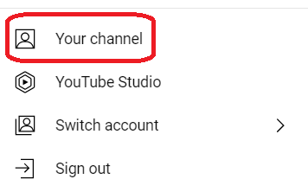

How to Add Videos to YouTube
- Select the “Manage videos” button on the right side of the middle pane
- Choose the “Create” button and select the "Upload videos" option from the subsequent drop-down menu
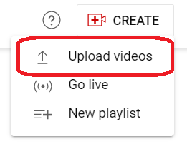
- Upload the video from your device
- Make sure to select the right language in the details window. It’s generally considered the best practice, and this will allow YouTube algorithms to create automatic captions
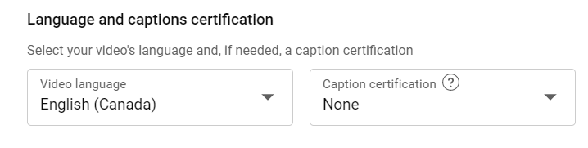
- Select the “Next” button in the lower right corner
- Select “Save” to upload the video to your channel
- Follow the same steps from above to upload the second video with transcribed audio
- Select the “details” button below the first video
- Insert the link to the second video with transcribed audio in the description field
- Select the “Save” button to save changes

Here are a few tips to consider when adding described audio:
- Consider the audience: Think about who the audience is and what their needs are when adding described audio.
- Use clear, concise language: Use language that is easy to understand and avoids technical jargon.
- Use descriptive language: Describe what is happening in the audio, including important sounds, actions, and dialogue.
- Consider timing: The timing of the described audio is important, as it should match the audio as closely as possible.
- Use tone and inflection: Use appropriate tone and inflection to convey the emotion and meaning behind the audio.
- Avoid over-describing: Avoid over-describing the audio, as this can be distracting and take away from the audio itself.
- Test the described audio: After adding the described audio, test it to ensure that it is accurate and accessible to the intended audience.
- Update regularly: Regularly update the described audio to ensure that it remains accurate and up-to-date.
Resources
Read a short article that demonstrates the importance of described audio: Why Audio Descriptions Need to Be a Priority for Your Content
An overview of described audio and its integration into YouTube
This work is licensed by St. Clair College under a Creative Commons Attribution-NonCommercial ShareALike 4.0 International License. Last edited: 2023-01-25

