Faculty Tech Tips Sheet

Quick Image Adjustment with Photo Tools (MAC)

An image that is a JPG, 400 pixels wide, and less than 500 KB is our target when uploading images to Blackboard. This image will present well on a laptop or mobile device and will load quickly. One quick way to adjust an image is to use the image editing software available by default on a Mac. It is called Preview.
NOTE Using Preview on Mac: When you go to save your image in Preview, it is more than likely you will be overwriting your original image. To prevent this, you should copy or duplicate your image before you save so you do not lose the original image.

Instructions
1. Open your image by double clicking or right clicking and selecting ‘Open’ from the menu.
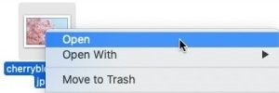
NOTE: If Preview doesn’t open, you can choose which software you want to open the image with by right clicking the image file and selecting Open With. You will see another menu appear where you can select Preview. This will force the image to open with Preview.
2.Select the Tools tab at the top of the page and from the menu that pops up select Adjust Size.
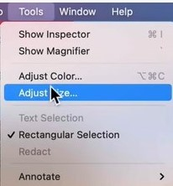
3. Input your desired width and height or select a predefined size by selecting an option from the Fit into: box. You can also change the resolution and units of measurement.
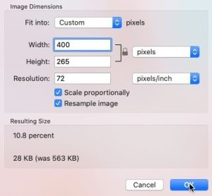
4. Select the OK button.
NOTE: ‘Scale proportionally’ should always remain checked when resizing.
5. Select on the File’ tab at the top of the page and from the menu that pops up select Save to save the edited image.
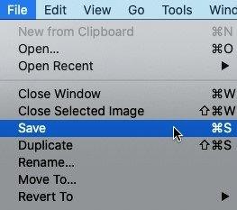

Resources
Resize, rotate, or flip an image in Preview instructions from Mac Support.
Using Preview for Mac to adjust an image – YouTube Tutorial
This work is licensed by St. Clair College under a Creative Commons Attribution-Non Commercial Share Alike 4.0 International License. Last edited: 2023-01-25

