Faculty Tech Tips Sheet

Quick Image Adjustment with Photo Tools (Windows)

An image that is a JPG, 400 pixels wide, and less than 500 KB is our target when uploading images to Blackboard. This image will present well on a laptop or mobile device and will load quickly. One quick way to adjust an image is to use the image editing software that is available on Windows. This is called Photos. Although this tool has other features, this tutorial will focus on how to resize an image.

Instructions:
1. Open your image by double clicking or right clicking and selecting ‘Open’ from the menu.
NOTE: If Photos does not open, you can choose which software you want to open the image with by right clicking the image file and selecting Edit with Photos. This will force the image to open with Photos.
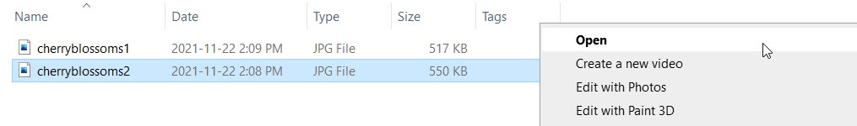
2. Select the 3 ellipses to open the options menu towards the top right of the screen. From the menu that pops up, select ‘Resize.’
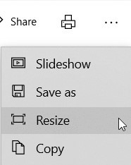
3. Select a predefined size (Small, Medium, or Large) on the Resize Image panel and it will shrink your image to that size. If you know the width you want to set your image to, you should select the Custom option, which is at the bottom of the list.
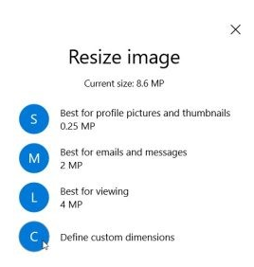
4. Input your desired width and height and adjust the quality of the image after selecting the custom option.
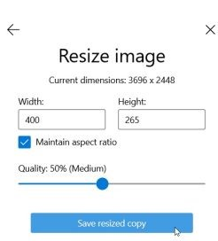
5. Select Save resized copy once you are done editing. NOTE: Maintain aspect ratio should always remain checked when resizing.

Resources
Instructions for Editing Photos from Microsoft.
Using Photos on a Windows Computer – YouTube Tutorial

This work is licensed by St. Clair College under a Creative Commons Attribution-NonCommercial ShareALike 4.0 International License. Last edited: 2023-01-25

