Faculty Tech Tips Sheet

Creating Accessible PowerPoint Slides

Regardless if you provide your PowerPoint Slides to your students before or after your class, there are a few design considerations that you can use while creating your slides that can make your Slide Decks more accessible for students.
Starting with the common Accessible Document tips, the following are recommended when creating PowerPoint Slides:
- Use a readable font - serif fonts such as Tahoma, Calibri, Helvetica, Arial, Verdana, and Times New Roman are recommended.
- Use default lists styles (bullets or numbers) to break up text and add organization.
- Use meaningful hyperlinks instead of listing the URL.
- Add alternate text to images (see our Tips on Alt-tags and Beyond Alt-tags).
- Identify document language which helps screen readers interpret your document (File - Options - Language, only needed once unless you create slides in different languages).
- Use the Accessibility Checker.
In addition, consider these tips specifically for PowerPoint:
- Use high contrast color schemes.
- Ensure color is not used as the only means of conveying information.
- Use at least 18 pt text, 28 pt is recommended for in-class presentations.
- Use a unique title for each slide.
- Use the preset slide templates and use Design after entering your text.
- Check reading order on slides.
- Avoid text on top of images.
- Avoid animations.
- Avoid adding additional textboxes.
- If the presentation is also provided as a printout, include the URL along with the hyperlink text.
- Create tables by using the PowerPoint’s Insert Table tool.

Instructions

How to Use Design in PowerPoint Online

Design Ideas is available in PowerPoint Online and can help you add a professional, coordinated look to your slide presentation.

- Open a blank presentation and add your text and images.

After you have added your content, return to your first slide and select Design and then Designer.
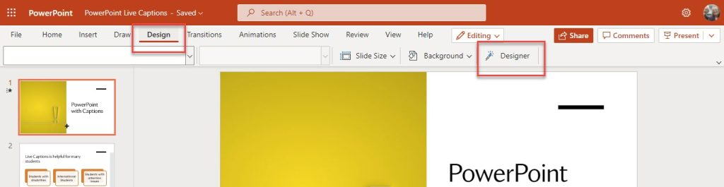

The Design panel will appear to the right of your slides and present you with Design Idea. When you find one you like, simply click on the slide in the panel and PowerPoint will apply the style to your slide. Move to your next slide to view the Design Ideas based on the content.

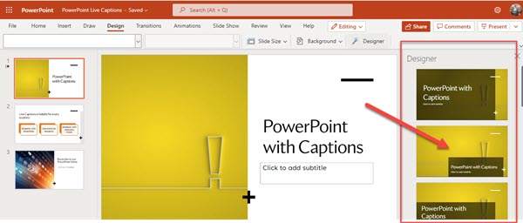

You can add your own images after you have entered text on your slide. Use Insert and Picture to add an image from your computer, OneDrive, or from Stock Photos. Design Ideas will show options that incorporate your image.

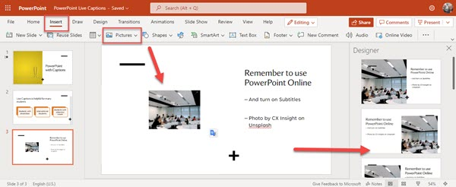

How to add alt text to an image in PowerPoint

- Navigate to the "Insert" tab on the ribbon at the top of the page
- Expand the “Pictures” option in the “Illustrations” section of the ribbon and choose “This Device…” button from the drop-down menu
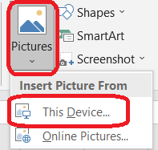
- Upload an image from your device
- Select the image you uploaded by using the secondary click and navigate to the “Format Picture…” button at the bottom of the drop-down menu. Using the “View Alt Text…” button is not recommended, as it doesn’t provide us with an option of creating Alt Text Title
- Navigate to the “Size & Properties” option in the “Format Picture” menu on the right side of the document and expand the “Alt text” option
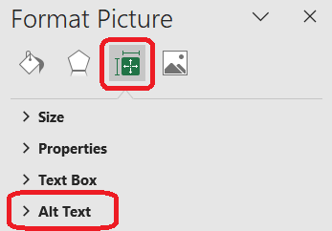
- Enter a brief and concise description of an image in the “Title” field and provide more information about the image in the “Description field”
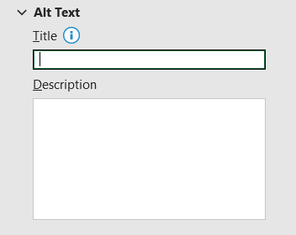
- Select the “Close” button in the upper right corner of the menu to save changes after you finish adding the alt text

How to test Microsoft PowerPoint document for accessibility

- Select the "File" tab from the ribbon at the top of the page
- Navigate to the "Info" section in the left-hand menu
- Select and expand the "Check for Issues" button in the middle pane
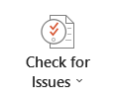
- Select "Check Accessibility" button from the drop-down menu
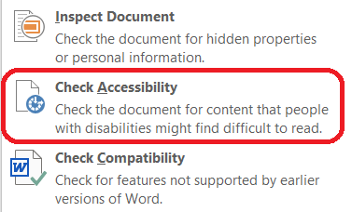
- Word will then perform a series of checks to identify potential accessibility issues in the document, such as missing alternative text for images, improper heading structure, or insufficient color contrast.
- Check the "Accessibility Checker" pane on the right side of the screen. MS Word will display a list of issues it found in this pane
- Review each issue and follow the instructions provided by Word to resolve them
- Follow the link in the “Additional information” section in the "Accessibility Checker" pane for additional guidance, if necessary
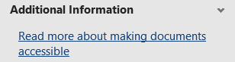
- Run the accessibility check again to ensure that no additional issues were introduced during the remediation process
- Save the document

How to check and change slide reading order

- Select the “Home” tab from the ribbon at the top of the screen
- Navigate and expand the “Arrange” option under the drawing section in the “Home” tab
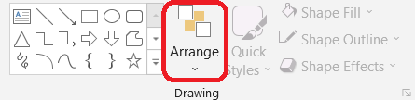
- Choose the “Selection pane” button from the “Position Objects” category of the drop-down menu
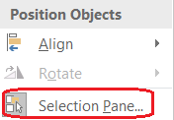
- Change the order by selecting the element and using the up and down arrows above the elements. Note that the selection pane shows what will be read first at the bottom of the pane
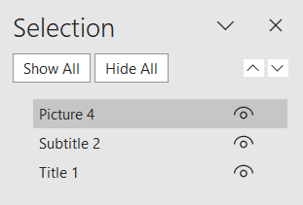

Resources
- Read a short article that demonstrates creating well-designed PowerPoint for people with disabilities: Make your PowerPoint presentations accessible to people with disabilities
- An overview of accessibility features in PowerPoint is available from WebAIM website
- A video walkthrough is available from Microsoft Support.
This work is licensed by St. Clair College under a Creative Commons Attribution-NonCommercial ShareALike 4.0 International License. Last edited: 2023-02-27

