Faculty Tech Tips Sheet

Adding Alternate Text to an Image in Blackboard Learn Original

The process for adding Alt Tags in Blackboard Learn Original is straightforward:
1. Select + from the Text Menu and select the image you want to insert.
2. Right click and select Image from the drop-down menu

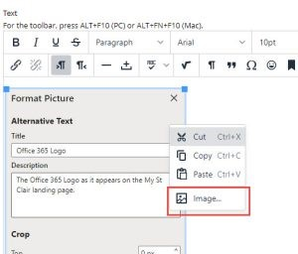
4. Add your alt tag to the box marked Alternative Text in the Format Picture dialog box.
5. Click Save.

Resources

Blackboard Guides: Insert Images in the Editor
- Adding Images to Blackboard video walkthrough
This work is licensed by St. Clair College under a Creative Commons Attribution-Non Commercial Share Alike 4.0 International License. Last edited: 2023-02-17

