Faculty Tech Tips Sheet

Adding Alternate Text to an Image in MS Teams Chat

Alt text (alternative text) is a description of an image or other non-textual content that provides context for users who may not be able to view the image. It’s important to know that Microsoft Teams does not provide its users with a traditional way of adding alt text to images, however, there is still a way to make your content more accessible.

Instructions
- Open Microsoft Teams on your device
- Start a new chat or open an existing one by selecting the “Chat” button from the menu on the left side of your screen

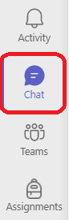
- Select the "Attach" button in the chat input box below the input field to open the file picker
- Choose whether you want to add an image from your device or OneDrive from the drop-down menu
  - 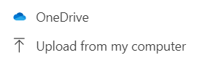
- Select the image you would like to upload
- Navigate to the “format” button in the chat input box below the input field
- Type a descriptive and concise text in the “Type a new message” field
  - 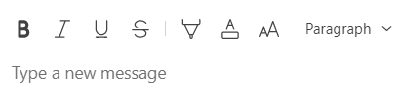
- Make sure that your image file name is also descriptive and concise
- Select the “Send” button on the right side of the input field
Resources
Read a short article that demonstrates the importance of adding alt text to an image: Add Alt Text to Images
An overview of alt text is available from WebAIM
This work is licensed by St. Clair College under a Creative Commons Attribution-NonCommercial ShareALike 4.0 International License. Last edited: 2023-01-06

