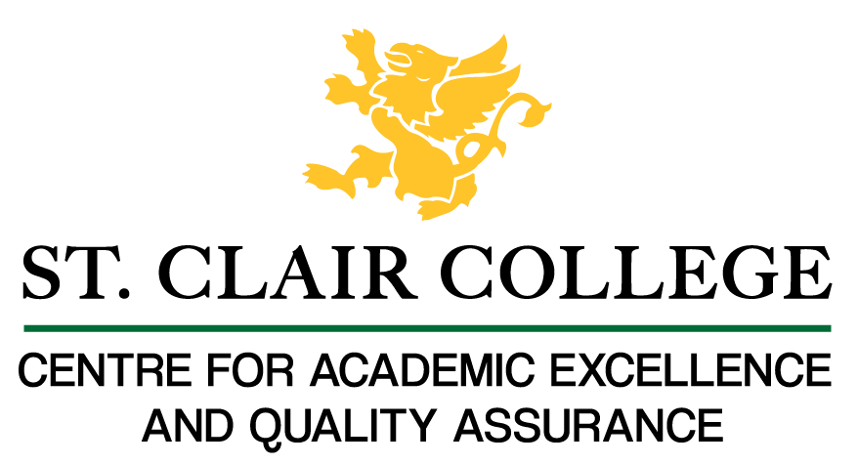
Faculty Tech Tips Sheet

Adding Captions to a Blackboard Collaborate Recording

Closed Captions in Blackboard Collaborate Recording are written text of the spoken content in a recording. They are typically displayed at the bottom of the video player. This option allows you to add captions to the recording and it can be turned on or off by the viewer.
Blackboard Collaborate provides several options for captions in their recordings:
- Automatic Speech Recognition (ASR): This option uses speech-to-text technology to automatically generate captions for the recording. The captions generated by ASR may not be 100% accurate, but they can be edited and refined as needed.
- Manual Captions: This option allows the user to manually type in the captions for the recording. This is a more time-consuming process but allows for more accuracy.
- Import captions: This option allows you to import captions from a file, such as a .srt file. This can be useful if captions have already been created for the recording by a professional captioning service or by another software.

Instructions
- Locate the recording you want to caption from the Collaborate Dashboard. The recording name always begins with the session name unless you changed it.
- Select three-dots menu on the right side of your recording.
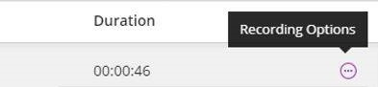
- Select “Add caption source” from the list of Recording options.
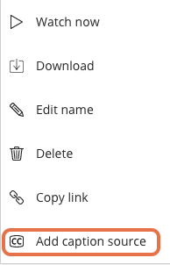
- Choose whether you want to create the captions manually or have Collaborate generate them for you using speech recognition technology from the menu.
- Select the “Enable captions” option first and then select “Create auto-caption” or “Upload/Overwrite captions” link depending on whether you need automatic captions or manually created captions.
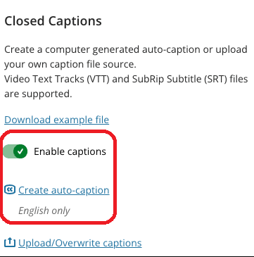
- Select the “Upload/Overwrite captions” link, browse for the SRT or VTT file on your computer and upload it if you decided to add manual captions.
- Select the “Submit” button at the bottom of the screen to save and submit the changes.

Resources
Read a short article that demonstrates adding captions to a recording in Blackboard Collaborate: How do I add captions to a Collaborate recording?
An overview of captions is available from Blackboard’s Class and Collaborate Support
This work is licensed by St. Clair College under a Creative Commons Attribution-NonCommercial ShareALike 4.0 International License. Last edited: 2023-03-02

