trrrf

Faculty Tech Tips Sheet

How to Add captions to a Recording on MS Stream

MS Stream is the video player that is part of MS 365 Live. Faculty can upload videos to MS Stream and share with their students. Video on MS Stream can be restricted so that viewers must have a St. Clair College log in to view. These videos require captions. Captions are text that appear on a video to provide a transcript of the spoken words or other relevant audio content. They are used to make videos accessible to viewers who are deaf or hard of hearing, but can also be beneficial for viewers who are not native speakers of the language being spoken, or who have difficulty understanding accents or technical terminology.

Instructions
- Sign in to your “MySt.Clair” account
- Select “Office 365 Apps” tab
- Navigate to the “Home” tab on the left side of the navigation menu
- Enter “Stream” into the search bar and select the Stream App icon.

How to add captions to the recording on MS Stream
- Select the “Upload” button on the right side of the “Quick access” menu
- Upload the video file from your computer or other storage device.
- Navigate to the “Open” button from the drop-down menu
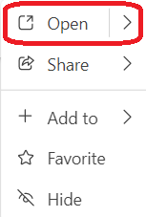
- Expand the “Video settings” tab on the right side of the window
- Navigate and expand “Transcript and captions” tab on the “Video settings” panel
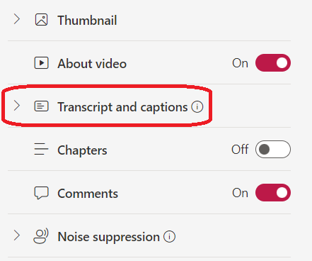
- Select the “Upload” button if you have a transcription file ready. OR
- Select the “Generate” button if you decided to add automatic captions and choose the spoken language from the pop-up window.
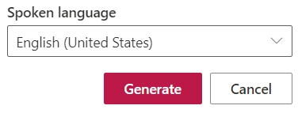
- MS Stream will begin to generate your captions and present a status bar of progress.
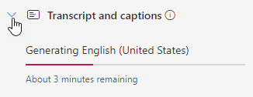
- Select Transcript from the Video Options menu and select a block of text to edit and make corrections.
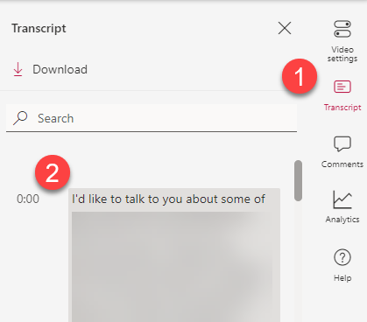

Resources
- Read a article from Microsoft support that demonstrates how to add Caption and how to autogenerate captions.
- A video overview of is also available eon YouTube.
This work is licensed by St. Clair College under a Creative Commons Attribution-NonCommercial ShareALike 4.0 International License. Last edited: 2023-03-02

