Faculty Tech Tips Sheet

Adding Alternate Text to An Image on Facebook

Alternative text (also known as "alt text") is important for images on Facebook because it helps users who are visually impaired or who use screen readers understand the content of an image. When an image is added to a Facebook post or page, the user has the option to add alt text to describe the image. This is especially important if the image contains essential information or is used as a link.

Instructions
- Open your web browser and go to www.facebook.com
- Log in to your Facebook account
- Go to the page or profile where you want to add an image.

How to Add Alternate Text to An Image
- Select on the "What’s on your mind?" field to create a new post or select the "Photo/video" button to add an image to an existing post.
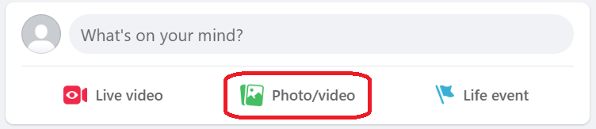
- Choose and upload the image you want to add from your computer or device
- Select the picture and click on the “Edit” button.
- Select the "Alternative text" button on the left-hand side to enter a description of the image.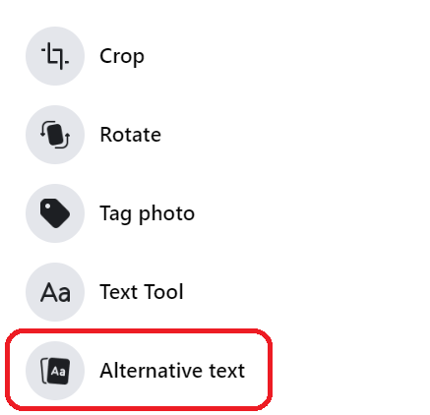
- Type a concise and accurate description of the image in the “Custom alt text” field.
- Select "Save" to close the image editor once you have entered the alt text,
- Preview your post to make sure everything looks good, and then select "Post" button to post your image with the alt text included.
- The alt text will now be added to the image. When the post is published, the alt text will be read by screen readers to users who are blind or have low vision.

Here are a few tips and tricks for adding alt text to images on Facebook:
- Keep it concise: Alt text should be short and to the point. Try to summarize the content of the image in one or two sentences.
- Be accurate: Make sure the alt text accurately describes the content of the image. Avoid using vague or misleading descriptions.
- Use keywords: If the image is related to a specific topic or concept, consider including relevant keywords in the alt text. This can help users who are searching for information on that topic to find your image.
- Avoid duplication: If you are including a caption or text in your post that describes the image, there is no need to repeat that information in the alt text. Instead, focus on providing additional context or details about the image.
- Preview your post: Before you post your ideas and images, make sure to preview it to ensure that the alt text is displayed correctly and that the image looks good. This will help you catch any errors or formatting issues before you select "Post" button.

Resources
Read a short article that demonstrates adding alt text to an image on Facebook: Adding Alt Text to Images on Facebook
An overview of Alt Text is available from Facebook Help Center
This work is licensed by St. Clair College under a Creative Commons Attribution-NonCommercial ShareALike 4.0 International License. Last edited: 2023-01-25

