Faculty Tech Tips Sheet

Adding Alternate Text to An Image on TikTok

Alternative text (also known as "alt text") is important for images on TikTok because it helps to make the content on TikTok more accessible to people with disabilities, such as those who are blind or have low vision. By providing a text description of the image, alt text allows these users to understand and engage with the content on the platform. Alt text can improve the user experience for people who are using a slow internet connection or have limited data on their device. In these cases, images may not load properly, but the alt text will still be visible, allowing users to get a sense of what the image is about.

Instructions
- Open your web browser and go to www.tiktok.com
- Log in to your TikTok account
- Go to your profile page by selecting your profile picture in the upper right corner of the website and selecting “View profile” button in the menu.
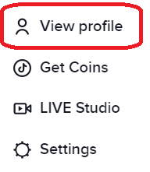
How to Add Alternate Text to An Image
- Navigate to the ribbon at the top of the website and select “Upload” button to upload images to your TikTok.
- Upload the image from your computer by selecting “Select file” button 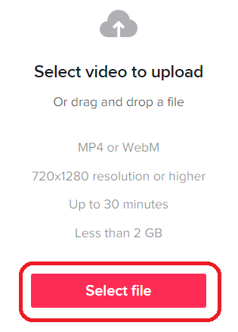
- Locate and select the “Caption” field at the top of the “Upload video” window.
- Type a concise and accurate description of the image in the “Custom alt text” field.
- Preview your post to make sure everything looks good, and then select "Post" button at the bottom of the window to post your image with the alt text included.
- The alt text will now be added to the image. When the image is published, the alt text will be read by screen readers to users who are blind or have low vision.
Here are a few tips and tricks for adding alt text to images on TikTok:
- Keep it concise: Alt text should be short and to the point. Try to summarize the content of the image in one or two sentences.
- Be accurate: Make sure the alt text accurately describes the content of the image on TikTok. Avoid using vague or misleading descriptions.
- Use keywords: If the image is related to a specific topic or concept, consider including relevant keywords in the alt text. This can help users who are searching for information on that topic to find your image.
- Avoid duplication: If you are including a caption or text in your post that describes the image, there is no need to repeat that information in the alt text. Instead, focus on providing additional context or details about the image.
- Preview your image: Before you post your ideas and images, make sure to preview it to ensure that the alt text is displayed correctly and that the image looks good. This will help you catch any errors or formatting issues before you select "Post" button.

Resources
Read a short article that demonstrates adding alt text to an image on Facebook: How to Add Closed Captions and Subtitles to TikTok Clips
An overview of Alt Text is available from Artlist Blog
This work is licensed by St. Clair College under a Creative Commons Attribution-NonCommercial ShareALike 4.0 International License. Last edited: 2023-01-06

