Faculty Tech Tips Sheet

Live Captioning and Transcripts in MS Teams

MS Teams Live Captioning and Transcripts can provide numerous benefits for students, including improved accessibility for those with hearing disabilities or language barriers, enhanced learning experience through written records of lectures, better note taking, increased engagement, and a more inclusive learning environment. MS Teams Live Captioning and Transcripts can also assist faculty and staff through improved record keeping through written records of virtual meetings.

Instructions
Both Captions and Transcription are options available under the More menu denoted by three ellipses (1) on the menu bar. You will need to use the downloaded version of MS Teams for these services. They will not work in MS Teams accessed through a browser window.
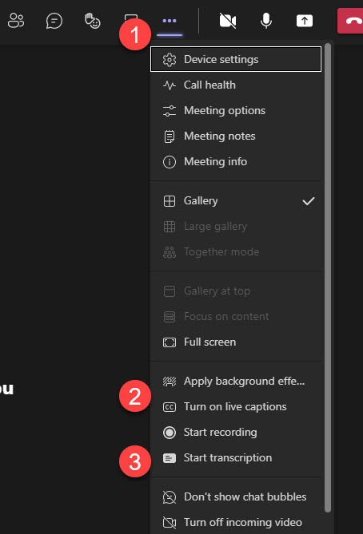
- The More menu
- Captions menu item
- Transcription menu item

Captions in MS Teams
You can turn on captioning in any MS Teams meeting.
- Join the meeting.
- Select the three ellipses on the menu bar at the top of your window to access the More menu and select Turn On Live Captions. The captions will appear the bottom of your screen. When a person speaks, their words appear beside their name and avatar in the caption area.
- Open settings, the three ellipses in the right top corner of the caption window and change the spoken language if needed.

Resources
- For further instructions, including how to use Live Caption on your mobile device, check out Use Live Captions in a Teams Meeting.
- Watch a short instruction video by Mike Tholfsen: How to use Live Captions in Microsoft Teams

Transcription in MS Teams
Transcription works best in a meeting set up through the calendar as the transcription file will be available to download from the calendar entry after the meeting has ended. The transcription will appear beside the meeting window as it is being generated.
- Join the meeting.
- Select the three ellipses on the menu bar at the top of your window and scroll to Start Transcription. The Transcription will appear on the right side of the MS Teams viewing screen.
- Download the transcript after the meeting is over by opening the calendar appointment. It will appear under Recordings and Transcripts.
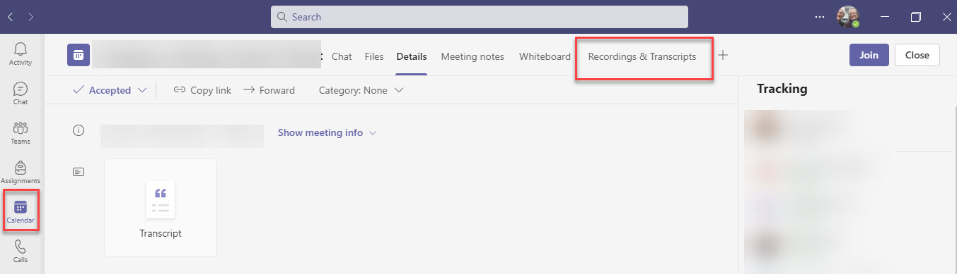

Resources
- A written overview of Transcripts in Teams is available through Microsoft.
- Watch a short video that demonstrates both Captions and Transcripts from Mike Tholfsen: Microsoft Teams meetings Transcription | Get transcripts and Live captions for your meeting.
This work is licensed by St. Clair College under a Creative Commons Attribution Non Commercial Share Alike 4.0 International License. Last edited: 2023-02-01

