Faculty Tech Tips Sheet

Creating well-designed PowerPoints

Microsoft PowerPoint is a powerful tool for creating presentations, and it provides several options to help ensure that your presentations are accessible to all audience members, including those with disabilities.
Proper design of a presentation is important for accessibility because it helps ensure that all audience members, including those with disabilities, can understand and engage with the content. A well-designed presentation should be easy to read, understand, and navigate, regardless of the audience member's abilities or disabilities.
In addition to the design considerations mentioned above, PowerPoint also provides specific accessibility features that you can use to make your presentations more accessible, such as:
- “Design” tab that allows the creator to change the design of their slides in Microsoft PowerPoint. It offers a range of templates, color schemes, fonts, and backgrounds to choose from.
- "Slide Master" feature that also allows the creator to control the overall design of their presentation and maintain consistency across all slides.
- "Selection pane" feature that allows for rearranging the slide elements’ order.

By considering accessibility in the design of your presentation, you can help ensure that all members of your audience can understand and engage with the content, regardless of their abilities or disabilities. This not only makes your presentation more inclusive, but also enhances its overall effectiveness by reaching a wider range of audience members.

Instructions
- Open Microsoft PowerPoint on your device
- Create a slide and add all the necessary elements such as text, pictures or videos

How to change design of the PowerPoint slides
- Select the “Design” tab from the menu ribbon at the top of the screen
- Navigate and expand the “More” menu arrow on the right side of the design templates row
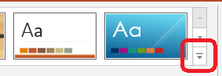
- Select the necessary slide design from the panel, and PowerPoint will apply the style to your slide.

How to check and change slide reading order
- Select the “Home” tab from the ribbon at the top of the screen
- Navigate and expand the “Arrange” option under the drawing section in the “Home” tab
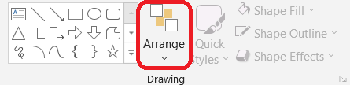
- Choose the “Selection pane” button from the “Position Objects” category of the drop-down menu
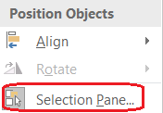
- Change the order by selecting the element and using the up and down arrows above the elements. Note that the selection pane shows what will be read first at the bottom of the pane
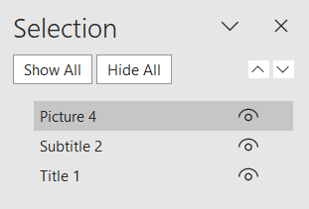

Here are a few tips to consider when creating PowerPoints:
- Use a readable font: Serif fonts such as Tahoma, Calibri, Helvetica, Arial, Verdana, and Times New Roman are recommended for presentations as they are easy to read on a screen
- Use default list styles: Breaking up text into bullet points or numbered lists can help make the information easier to digest and understand
- Use meaningful hyperlinks: Instead of listing the URL, provide a descriptive name for the link that conveys its purpose
- Add alternate text to images: Adding alternative text to images helps individuals with visual impairments understand the content.
- Identify document language: Specifying the language of your document helps screen readers interpret your presentation correctly. You can do this by going to "File" > "Options" > "Language."
- Use the Accessibility Checker: PowerPoint includes an Accessibility Checker that can scan your presentation for common accessibility issues and provide suggestions for improvement.

Resources
Read a short article that demonstrates creating well-designed PowerPoint for people with disabilities: Make your PowerPoint presentations accessible to people with disabilities
An overview of accessibility features in PowerPoint is available from WebAIM website
This work is licensed by St. Clair College under a Creative Commons Attribution-NonCommercial ShareALike 4.0 International License. Last edited: 2023-01-25

