Faculty Tech Tips Sheet

Image Editing with BeFunky

Introduction
BeFunky is an online tool used to compress image size. An image that is a JPG, 400 pixels wide, and less than 500 KB is our target for uploading to Blackboard. This will display well and load quickly.

Instructions
1. Upload your image by selecting Open and choosing your image.
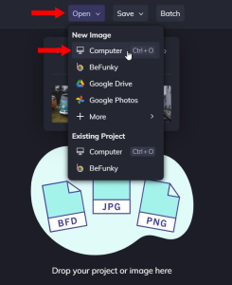
NOTE: On the left-hand side, make sure you are in the Edit tab, and you have the sub-tab Essentials expanded (this is the default when opening a new image).
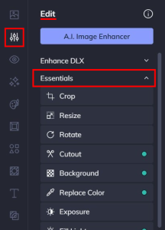
2. select 'Crop' or 'Resize' in the sub-tab Essentials.
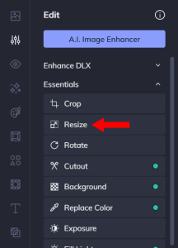
2.1 Using Resize, adjust the width and height on the left side to change the size. Select Apply to save your change.

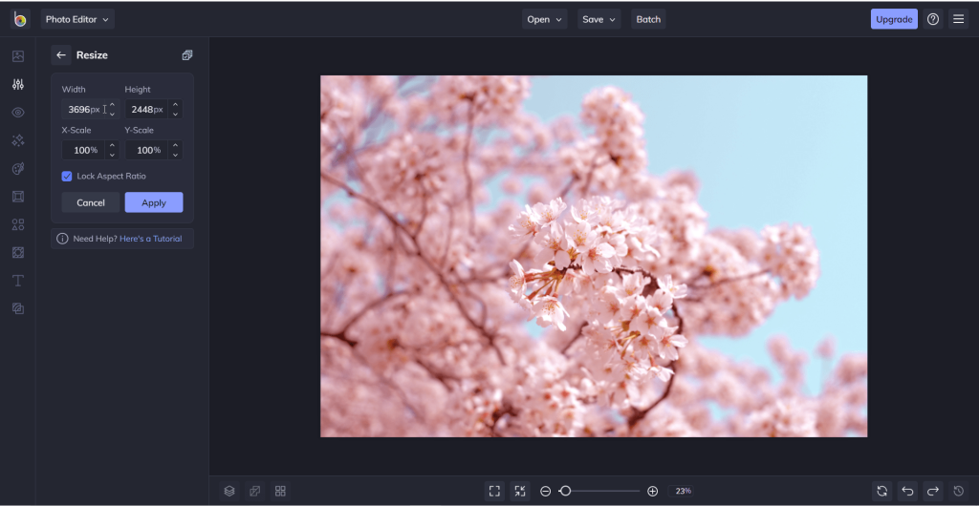
NOTE: Lock Aspect Ratio should always remain checked when resizing.
2.2 Using Crop: A box that looks like a grid will appear on your image.
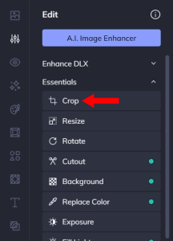
Everything that is inside of the box will stay in your image, while everything left outside of it will be cut out. Drag the edges of the box to adjust and position it.
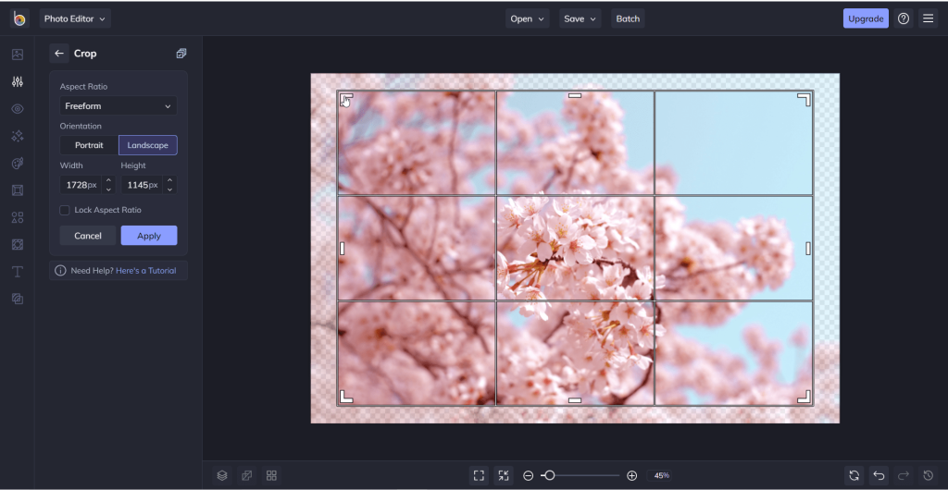
If you already know the width and height you need, you can also change the values directly in the width or height boxes on the left. Select Apply to save your change.
3. Select Save at the top of the screen and then select Computer from the drop-down menu to Save Your Image.
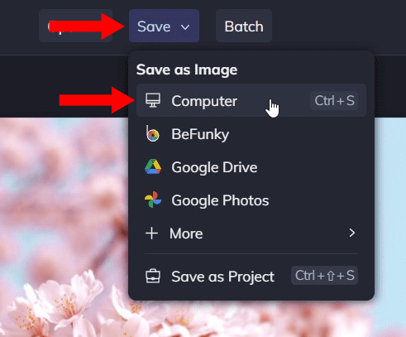
Note: This will not download the image immediately. Instead, you will be brought to a screen where you can change the filename, the extension type, and adjust the quality of the image. You do not have to change any of these values. However, we recommend that you use a JPG filetype.
4. Select Save to download the image.
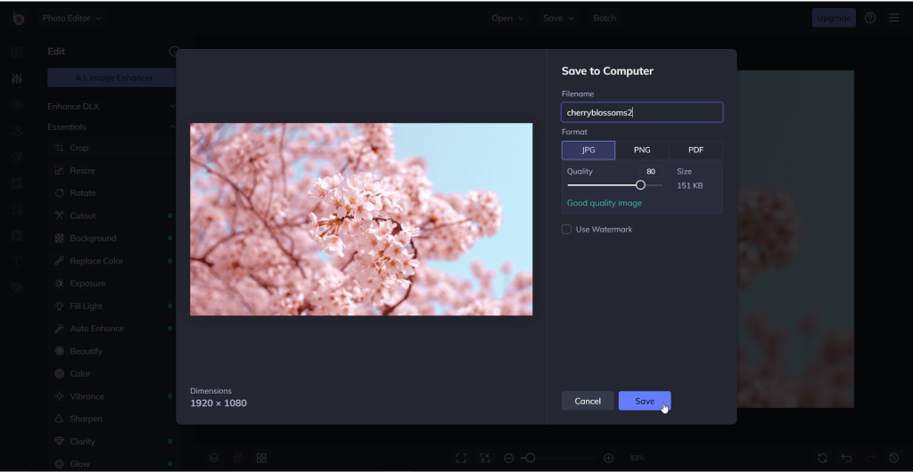
Resources
Instructions on how to resize an image from BeFunky Support.
Article and video walkthrough from BeFunky Support.
This work is licensed by St. Clair College under a Creative Commons Attribution-Non Commercial Share Alike 4.0 International License. Last edited: 2023-01-25

