Faculty Tech Tips Sheet

Google Chrome Live Captioning for PC and MAC

Blackboard Collaborate does not currently provide a method of Live Captioning during online classes. Live captioning through Good Chrome browser puts the power of live caption in the hands of students. With Live Caption feature on Google Chrome, you can automatically generate real-time captions for media with audio on your browser.
These captions will be created on your device after downloading a small speech file. Live Caption on Chrome works with both live and recorded content (offline and online), so you can even caption a recording of a Collaborate session when you play them in Chrome.
Please note that like any other captioning service this is not fully accurate and may produce occasional mistakes particularly when using certain terminologies or a strong accent.

Instructions
To Open the Google Chrome Settings Menu:

For PC:
Click on the 3 vertical dots in the top right corner of the Chrome browser window
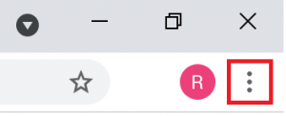

For MAC:
Click on Chrome -> Preferences

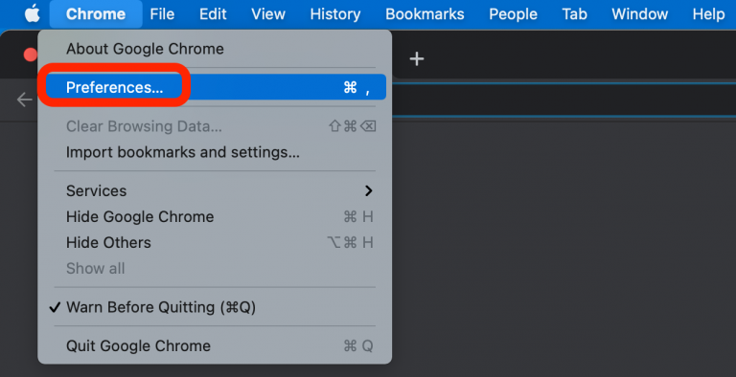

For both PC and MAC:
- From the Customize/Preferences menu, select Settings
- Expand Advanced on the left of the screen
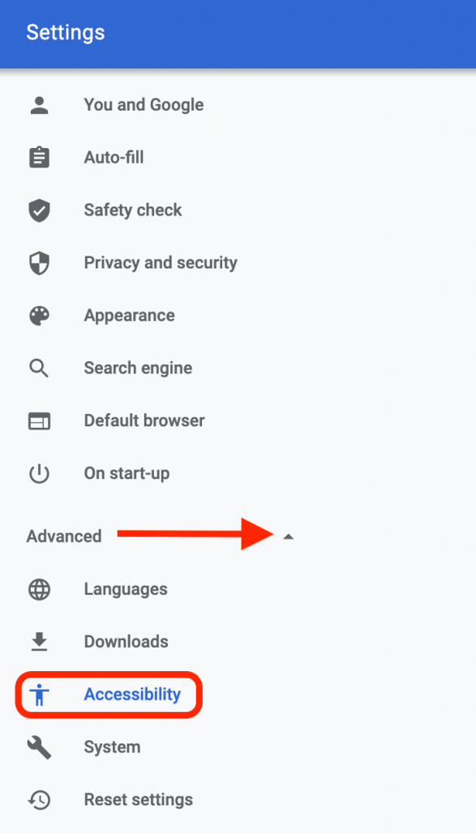
- Select Accessibility
- Enable the live caption slider in the centre of the screen. Your live captions should now display for any audio/video content being played on your Chrome browser.
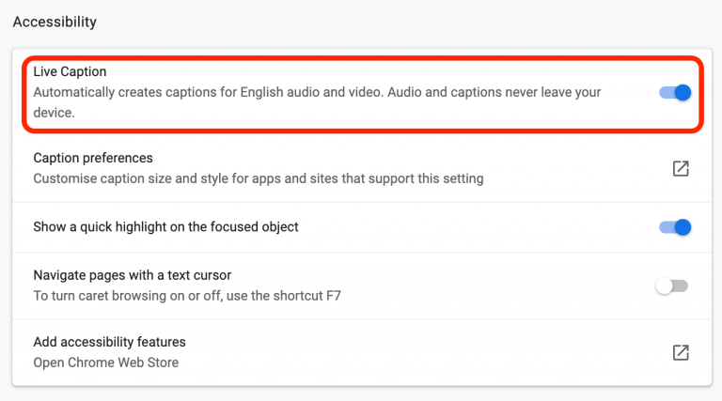
- Drag the Caption box to the preferred location on your screen.
- Return to the Settings – Advanced – Accessibility menu and select Caption preferences to adjust the size, background, and color of the text if needed.

Resources
- A written overview of Live Captions is available from Google Help
- Watch a short video that demonstrates Live Captions from Google Chrome: Enable Live Captions from Google Chrome
Adapted from Captioning on Blackboard Collaborate by the E-Learning Unit at Queen Mary University of London under CC BY NC SA
This work is licensed by St. Clair College under a Creative Commons Attribution-Non Commerical Share Alike 4.0 International License. Last edited: February 1, 2023

